**Policy Management System**

**Registration Page:**

1.       Create a page like this in Angular

2.       Angular component to make a HTTP POST method to the Spring MVC REST Controller

3.       The service has to store the data into the database

4.       Create a table in MySQL database to store these details

5.       Reset must clear the fields

6.       Submit must invoke the HTTP REST call from Angular.

7.       On Successful registration, the page has to be redirected to a new success page.

**Validations to be done in Angular:**

1. All the information’s are mandatory.
2. Valid Email Id
3. Contact should contain number.
4. Date of birth cannot be after the current date.
5. Password and confirm password should match.

**Screen 1 requirement**

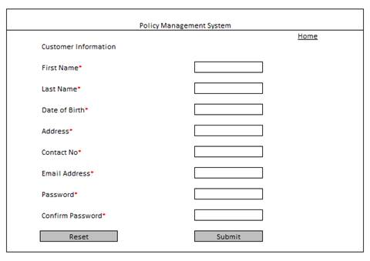

**Screen 2 requirement**

After associates register successfully, the below page must be displayed.

1.       User name is the name of the user

2.       Available Policies table – must be the MASTER list of policies (irrespective of user) – must be retrieved from the MASTER POLICIES table (this table is something you can create with some sample policy details; policy name example: Dental Plus Premium Policy; policy details example: This policy covers tooth implantation and other dental surgeries.)

3.       Second Table – contains user specific policies

a.       For the given user, retrieve the policy name, amount paid, end date and validity (this data can be pre inserted for some users). For a new registered user, this table will be empty.

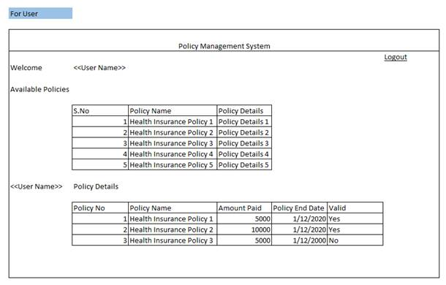

**Screen 3 requirement**

Login page. The user ID and Password must be validated against the USER table in the database. If success, the user has to be redirected to Screen 2 (Policy Details Page).

If failed, the same page must get refreshed with message ‘Login Failed’.

Clicking on Register must take to screen 1.

Please do not worry about styling in the view.

